Readme_Interactive Web Map_VGI

**How to Use the Map and File summary**

**Section 1: How To Use The Map**:

In order to use the interactive web map please go to the following link: [IL Schools.](http://usgs.github.io/NMC-volunteermap/NMCvolunteermapmaster/NMCvolunteermapmaster/NMCvolunteermapUpdate/)

Once the link opens you can zoom in using either the zoom buttons located on the bottom right hand side of the webpage or by using the scroll ball on your mouse.

Once you have zoomed into a specific location click on a red or green point this will bring you to the editor and allow you sign in and edit the point.

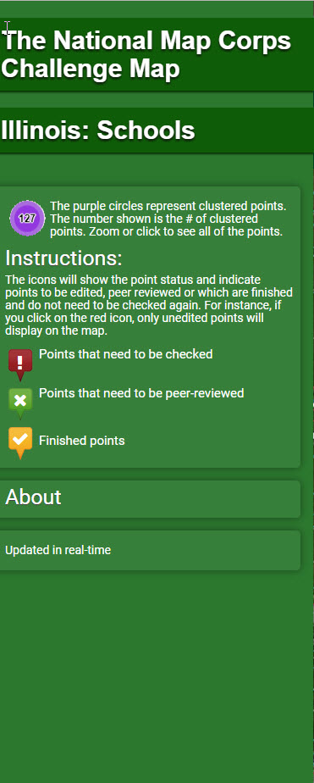

**Section 2: Files found in this Repo**

The files that are stored within this repo are in two groups, 1.) Primary Files and 2.) Secondary Files each of these file types will be described in more detail.

**Primary files**:

For this repo there are three main files these consist of the following:

1. Index.html file: This file houses all of the base maps, Images and icons for the IL Schools.
2. schools _script.js: This Javascript file houses the data and base maps for IL Schools.
3. Style.css: This CSS file houses all of the style code for the interactive web map. Including the color codes for the cluster points.

**Secondary Files**:

The following files contain the Geojson and the libraries needed to run the interactive web map

1. Asset files: These files consist of the CSS file, the img file and the plugin files
2. Data files: This file houses the geojson file for the IL Challenge Map.

**Section 3: Summary:**

The USGS Topo production team has a set schedule of the states that will be up for review throughout the year. The next challenge map is determined by Structures Supervisor and TNMCorps team lead.

The code for this interactive web map is stored on the [USGS TMNCorps Volunteer - Map Github](https://github.com/usgs/NMC-volunteermap)

**Developer Documentation**

**Section 1: Software Requirements**

In order to create the interactive web map, you will need some software in order to test the challenge map and write the code:

First, request a text editor, ( you will need to go through your supervisor for this) the text editor that I used for this challenge map was Brackets 1.6.0 By adobe, an open source text editor. You can use Atom, or Notepad++. Just ensure that your text editor can handle multiple languages. Brackets, can handle Javascript, HTML and CSS.

Second request Node.js 8.9.3, (you will need to go through your supervisor for this as well) Node.js is a command prompt that allows you to connect to a local server that will test your code.

Third request gitbash 2.14.2, again you will need to ask supervisor approval for this software. Gitbash allows you to push and pull the code from github to your local machine and allows you to see the history of the code as it changes over time.

**Section 2 : Creating the IL Schools Challenge Map Step by Step Guide:**

Step 1: Download the code from Github, by going to gh-pages branch and download the [TMNCorps Challenge Map](https://github.com/usgs/NMC-volunteermap)

Step 2: Once downloaded, rename this file to the challenge map you are making.

Step 3: Make a copy of this file and name it Test_ChallengeName

:The three files that will be the main focus of this interactive web map are:

a.) HTML file - This is the front facing code that shows the interactive challenge map.

b.) Javascript file - This file conducts all the work, this file holds your basemaps, your data for the challenge map, and the functions for clustering your points.

c.) CSS file - This file is responsible for the design aspects of the interactive web map and the overall web page.

**Section 3: Overview of Primary Files**

HTML

Lines 4 - 29: These lines consist of the title and various links and scripts that are in the background of the mapping application. Such scripts consist of leaflet, leaflet - esri, leaflet markers etc.

Lines 30 - 35: These are the div classes that build the basic outline of the mapping application.

Lines: 36- 37 is the Title of the challenge map in question, rename it to reflect the new state and structure type that is specific for that challenge map.

Lines 40 - 49 This block of code houses the cluster image for the legend and structural pieces of code for the website.

Lines 52 - 56 This block of code is the write up for the challenge map for explanations for the clustering and the icons buttons in the legend.

Lines 59-63 pertain to the clusters, depending on the number of points you have for your challenge map, you may or may not need this information. If you have more than > 1000 points, I suggest keeping the clustering.

Lines 56 - 79 are the div classes for each grouping of points. Unedited, peer reviewed and finished points respectfully.

Lines 87 - 91 create the “About” Button for the interactive web map.

Lines 86 - 95 Create the statement for “updated in real time” Line 91** connects the HTML file with the JS file. A path name is required for this document.

Lines 113- 116 Houses the text for the “About” Section with links to The National Map and our mapping challenges.

The rest of this document does not need to be updated. However your supervisor may request you to make changes to the “About” section. If so, go to Lines 105 to 108 to make those changes.

Javascript File

Lines: 2 - 20: These are the different basemaps that are being used to render this mapping application. Currently, there are only two base maps for the challenge map, USGS Topo and the USGS Imagery, The last basemap only loads at zoom level 14 through 19 in order to help ensure that there is imagery for every level that a user could zoom into.

The following basemaps that were used for this project consist of:

1. USGSImagery Pathname: 'http://basemap.nationalmap.gov/arcgis/services/USGSImageryTopo/MapServer/WmsServer?
2. USGS Topo : http://basemap.nationalmap.gov/arcgis/services/USGSTopo/MapServer/WmsServer?
3. USDA Topo: https://gis.apfo.usda.gov/arcgis/rest/services/Base_Maps/Base_Map/MapServer

Lines 23 - 35 Are commented out and consist of other basemap options.

Lines 38 - 44: Are layer groups for the three layers of points that are apart of this challenge map

Lines 47 - 94 This is the feature lay group for the clustering of the points.

*Note*: Line 46 and 47 are important in this block of code. Line 46 is where the endpoint api goes. And Lines 47 is the query for the feature type you are hoping to focus on.

Lines 96 - 98 Is your bounding box, for the area you wish to focus the map.

Lines 100 - 117 Are commented out; but consist of zoom controls for the other basemaps not used in this specific basemap.

Lines 120 - 125 The map variable creates a container for the code, that also involves the two basemaps that are being used in the application.

Lines 127 - 134 These commented out lines are old code from the previous map challenge; this code is being kept for historical information.

Line 135 Is the zoom control that allows a user to zoom in and out with a button in addition to their zoom wheel.

Line 137 - 142 Is the variable that houses the basemap names. Two lines are commented out that reflect the two basemaps that are not currently being used for this challenge map.

Lines 144 - 146 These lines create a button on the web map that allows a user to select which basemap they want to use.

Lines 147 - 178 These lines are commented out and are old code for data, basemaps layers and pointing to the layer being used.

Lines 180 - 214 This block of code is for the different point groups and the number associated with that grouping of points per the endpoint API.

Lines 216 - 224 This block of code controls the icons in the legend and allows users to turn them on and off and see only that layer.

CSS File

The CSS file, controls the overall look and design of your web map.

Lines 2-8: Create the physical space for the entire site.

Lines 10 -14: Gives the height and width of the map.

Lines 16- 18: No underline features and the background color and width for the info section of the web application.

Lines 20 -35 : This block of code focuses on the header of the web map application. H1 is the size of the text.This block of code breaks down what the font will look like given these parameters.

Lines 32-46: This block of code focuses on any code that uses an h2 distinction.

Lines 47-57: This block of code is after the first block of h2 text. Again, this block focuses on what h2 will look like. Notice it does not give a font family and focuses strictly on the position and width of the h2 text in this block.

Lines 58 - 76: .info and .info h4 go together to show the design components for the ‘about’ section of the interactive web map. It provides the font family and the color of the font located in this section.

Lines: 77 - 91: This block of code controls the image for the cluster points in the legend and on the map. Showing the size and width of the icon

Lines 92 -113: This block of code create the legend and the markers (Finished, Need to be checked and Need to be peer reviewed).

Lines 114 - 124: show the features that the legend is capable of,. Such as hoving over each icon.

**Section 4: Code that needs to change**

The code for this challenge map already has a laid out foundation, there are only specific lines within each of the three documents that you need to change in order to make your challenge map function: Let’s start with the HTML Document:

**HTML**

Lines: 36- 37 Change the Title of the Challenge Map to reflect the new state. (ex. Illinois to Louisiana)

Lines 48 - 51 You may need to change this block of code if you choose not to use the cluster points, or if you choose to change the icons.

Lines 100-113: If you need to add anything to the about section, you will want to add it here. This may or may not need to be changed.

**Javascript:**

Lines 44-91: Line 47 is where this needs to be changed, this is the query for the feature layer and the state that is called from the API endpoint.

Lines: 93-95: This is the bounding box, When you make a new map for the next challenge this bounding box will need to be changed to make that state the focus of the map.

**CSS:**

Line 77 - 91: If you decide to not use clusters you will need to remove the image from the legend, which is located in this block of code.

**Secondary Files**

The documents in these folders, do not need to be touched. Most of the libraries you will use are stored here in order to be called by the application.

**Assets**:

CSS: This is where the CSS file is stored that has been covered in depth.

Img - where all the images are located for the interactive web map. The cluster point image is located in this folder.

Plugins: these are the libraries that are used in building the interactive web may and they consist of:

* Esri-leaflet
* Leafelt
* Leaflet-awesome-markers
* Leaflet-cluster-markers
* Leaflet-extra markers
* Zip files of the above.